Portugal Tour Itinerary
TOUR INCLUDES:
- 7 overnight stays (9 with extension) in hotels with private bathrooms
- Full European breakfast daily
- Dinner daily
- Full-time services of a professional tour director
- Guided sightseeing tours & city walks as per itinerary
- Visits to select attractions as per itinerary
- Tour Diary™
- Note: On arrival day only dinner is provided; on departure day, only breakfast is provided
- Note: Tour cost does not include airline-imposed baggage fees, or fees for any required passport or visa. Please visit our Fees FAQ page for a full list of items that may not be included in the cost of your tour.

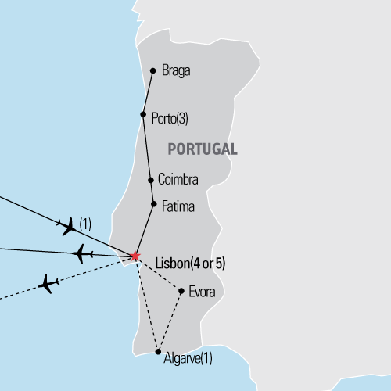

Day 1 Start tour
Evening activities and orientation

Day 2 Olá Lisbon
Arrive, checkin, eat lunch
Settle in and unpack
Meet your tour director and check into hotel

Lisbon city walk
This port city was once the entrance point for exotic wares from the far-flung corners of Asia, Africa and the Americas. Get lost in the Alfama, a maze of streets where houses are so close together, you can spread your arms and touch the buildings on both sides of the street! Stroll along the cobblestone pedestrian malls and Lisbon's main street, the Avenida da Liberdade.
- Rossio Square, Chiado quarter, Alfama quarter

Day 3 Lisbon--Porto
Travel to Porto via Coimbra & Fátima
Portugal's biggest university town, Coimbra has been a center of learning since 1290, when the country's first college was founded here. Fátima draws pilgrims rather than students. In 1917, three children saw several apparitions of the Virgin Mary in a field here, and the enormous basilica that was built in her honor attests to the continuing flood of pilgrims who visit the city each year.

Sanctuary of Our Lady of Fátima visit
Sanctuary of Our Lady of Fátima, the biggest pilgrimage site in Portugal. Located in the Centre of Portugal, the sanctuary of Our Lady of Fátima has become, throughout the years, the fourth biggest catholic pilgrimage site in the world, due to the apparitions of Virgin Mary to three little shepherds in 1917.

Coimbra University visit
History, tradition and charm. The University of Coimbra is the oldest Portuguese university and for centuries was the only university in Portugal. In June 2013, UNESCO classified it as World Heritage Site and during your time on campus you’ll quickly understand why.
University Library visit, Chapel visit
Built between 1717 and 1728, the University Library is also known as the Baroque Library in honor of King John V (1707-1750), who sponsored its construction and whose portrait, made by Domenico Duprà (1725), dominates the ornate space.

Royal Palace visit
The original chapel dates back presumably to the 11th century, built right after the conquest of the city from the Moors in 1064, just before the foundation of Portugal. It is dedicated to St. Michael, like all Portuguese Royal Chapels, because of his role in defeating the forces of evil. The Royal Palace. Purchased by the University from the Royal Family in 1597, the Royal Palace is where the most iconic rooms of the University are located, and where the most important traditional academic ceremonies take place.

Day 4 Porto landmarks
Porto guided sightseeing tour
Portugal's second largest city bustles with commerce, but its spectacular bridges (one designed by a disciple of Gustave Eiffel) and picturesque Ribeira district continue to draw visitors from around the world. Start your tour along the riverfront, where bright houses and intricate balconies rise haphazardly over narrow cobblestone streets. Continue on to the Church of São Francisco, whose plain exterior belies the dripping-with-gold Baroque magnificence of the interior. The Sé (cathedral) is only slightly less elaborate, with marble and stone substituting for gold leaf. The silver altarpiece in the Chapel of the Holy Sacrament and the typically Portuguese azulejos (tiles) add to the beauty.

Ribeira district, Sé Cathedral, Church of São Francisco

Day 5 Porto
Braga & Guimaraes guided excursion
See Portugal's religious capital at Braga, which erupts during Easter week with enormous colorful processions through the medieval streets. Guimarães is called the birthplace of Portugal; it was here that King Afonso Henriques began his reconquest of the country, leading it to expand to its current borders. The famous castle that dominates the skyline evokes this past, while the university students drinking coffee beneath its shadow guarantee the country a bright future.

Cathedral of Braga visit, Bom Jesus do Monte, Sameiro Sanctuary visit
Day 6 Porto—Lisbon

Scenic drive through the Douro Valley
Admire the world's most beautiful wine region as you make your way from Porto to Peso da Régua, through the terraced hillsides at the heart of the Douro Valley.

Travel to Lisbon

Day 7 Lisbon landmarks
Lisbon guided sightseeing tour
See the Castelo de São Jorge, a castle dating back to the Middle Ages, which sits formidably overlooking the city and its port. The Monument to the Navigators, dedicated to various important figures in Portugal’s history, depicts Henry the Navigator, and other explorers on top of a caravel, the standard Portuguese ship used for sailing expeditions. Take an elevator to the top of the monument for an impressive view of the city. Finally, travel to the vast Jerónimos Monastery, an awe-inspiring structure that is considered to be one of the most prominent monuments in Lisbon.

Mirador de Santa Justa, Monument to the Discoveries, Mosteiro dos Jerónimos visit, Belém Tower

Day 8 Sintra & Cascais
Sintra & Cascais guided excursion
One of the oldest and most lovely towns in Portugal, with sleepy hillside villas and luxuriant flowering vegetation, Sintra was the favorite spot of Portuguese kings and queens. The poet Byron considered it "glorious Eden". See the National Palace, classified as a national monument because of its regal architecture. The Palace consists of several styles – Gothic, Mudejar, Manueline and Renaissance. Make special note of the amazingly colorful glazed tiles (azulejos). Visit the luxury resort town of Cascais and see the citadel that once served as a summer home for the King of Spain in the 16th century.

Fado evening
Portugal's version of the Blues, Fado means "fate" or "destiny," and its songs generally tell the tale of lost love or glory. Head to a Fado house in the Bairro Alto and see the singers swathed in black, accompanied by 12-stringed guitars, crooning their hearts out.

Day 9 End tour

Travel home

